Yellowhammer Survey 2024

This survey aims to gauge how Yellowhammers are doing now compared to previous surveys in 2001 and 2011. We are looking at their breeding distribution and abundance during the forthcoming breeding season.

Yellowhammers are iconic, easily identified birds of summer with a classic song. They occupy relatively small territories, typically 60 - 100 m of hedgerow venturing 20 m onto open ground, or a similar sized area of scrub and open ground. Typically the birds favour arable farmland with cereal crops as opposed to intensive grassland farmed for cattle.

The survey is open to the widest range of bird watching interests and expertise – so please get involved in this summer’s Yellowhammer hunt whether that be on a family walk, as an opportunity for young birders or as part of a closer look at your local patch. This is citizen science and we need your help with sightings and surveying between April and July. There are two levels of involvement for this survey – chose what to get involved with.

Level 1. Sightings - if you come across Yellowhammers during the survey period they will most likely be on their breeding territory and since they usually attempt two broods it keeps them busy for four months of summer.
Please help build a map of Yellowhammer distribution (2024) in Cumbria by posting any sightings on the mapping site https://canvis.app/2fnuJe from April through to the end of July.

Level 2. Surveying – OK, so if you can identify a Yellowhammer, have a rough idea of the sort of place they can be found and the size of the territory which they occupy, then please sign up to carry out the survey.

What’s involved?
You will need to carry out a 2 hour walk around a patch sometime in April/May and to revisit the same patch for another 2 hour walk in June/July while making note of Yellowhammer sightings/territories.

How big is a patch?
Well, to enable comparison with previous surveys there is a standard procedure; a patch is a
2 km x 2 km square from Ordnance Survey maps – known as a tetrad. Have a look at the map of tetrads with a history of occupancy from the 2008-11 survey, each symbol represents a tetrad.

Choosing a tetrad.
We aim to revisit 10% of the 2008-11 tetrads - see proposed tetrad maps. Contact the survey organisers to sign up for one or more of these as priority tetrads. Survey enthusiasts will cover more than one tetrad and a willingness to cover vacant tetrads will be much appreciated. You can also register for your own tetrad if you have a site of interest to add, but it would still need to be a tetrad survey.

Surveying.
Within a tetrad, plot a route which takes in areas of suitable habitat – hedgerows, scrub and cultivated fields and record Yellowhammer territories. Make use of roads, tracks, footpaths and where possible farmland – take care and ensure your own safety, exemplary adherence to Country Code is a must. You cannot cover the whole tetrad so just chose a suitable route. You can vary your route on the second visit, just aim to arrive at a total number of territories recorded on the recording form and submitted to the organisers at the end of July.

Contact the organisers, Mike and Lyn Mills at mike.lyn@talktalk.net Tel 01946 590616.

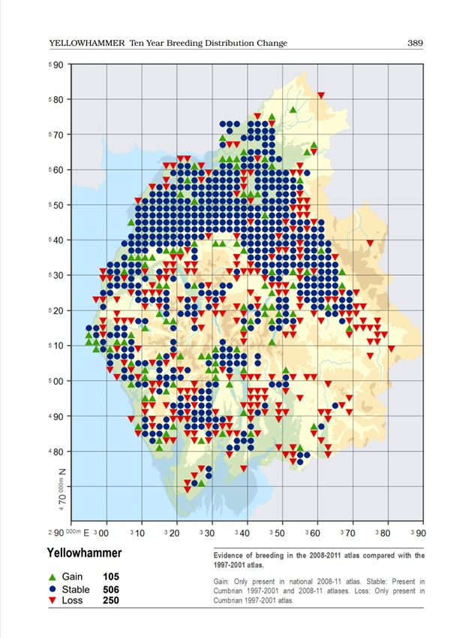 Note - a few of the proposed tetrads had gained Yellowhammers at the last survey, a few had lost them so proposed tetrads may have none or several Yellowhammer territories. For more information on tetrads and reference code, check out Correct grid references | BTO - British Trust for Ornithology

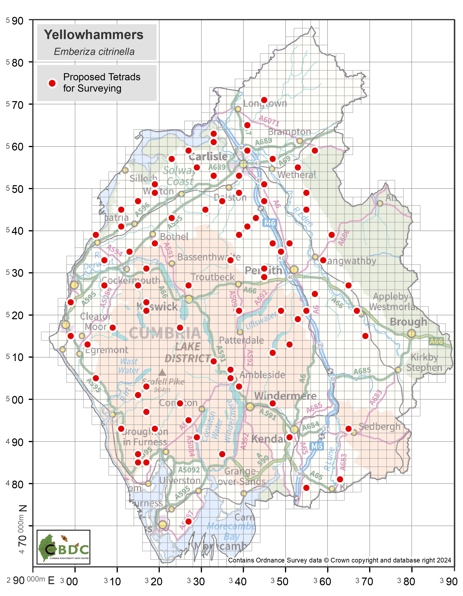
Figure 1: Survey tetrads by location

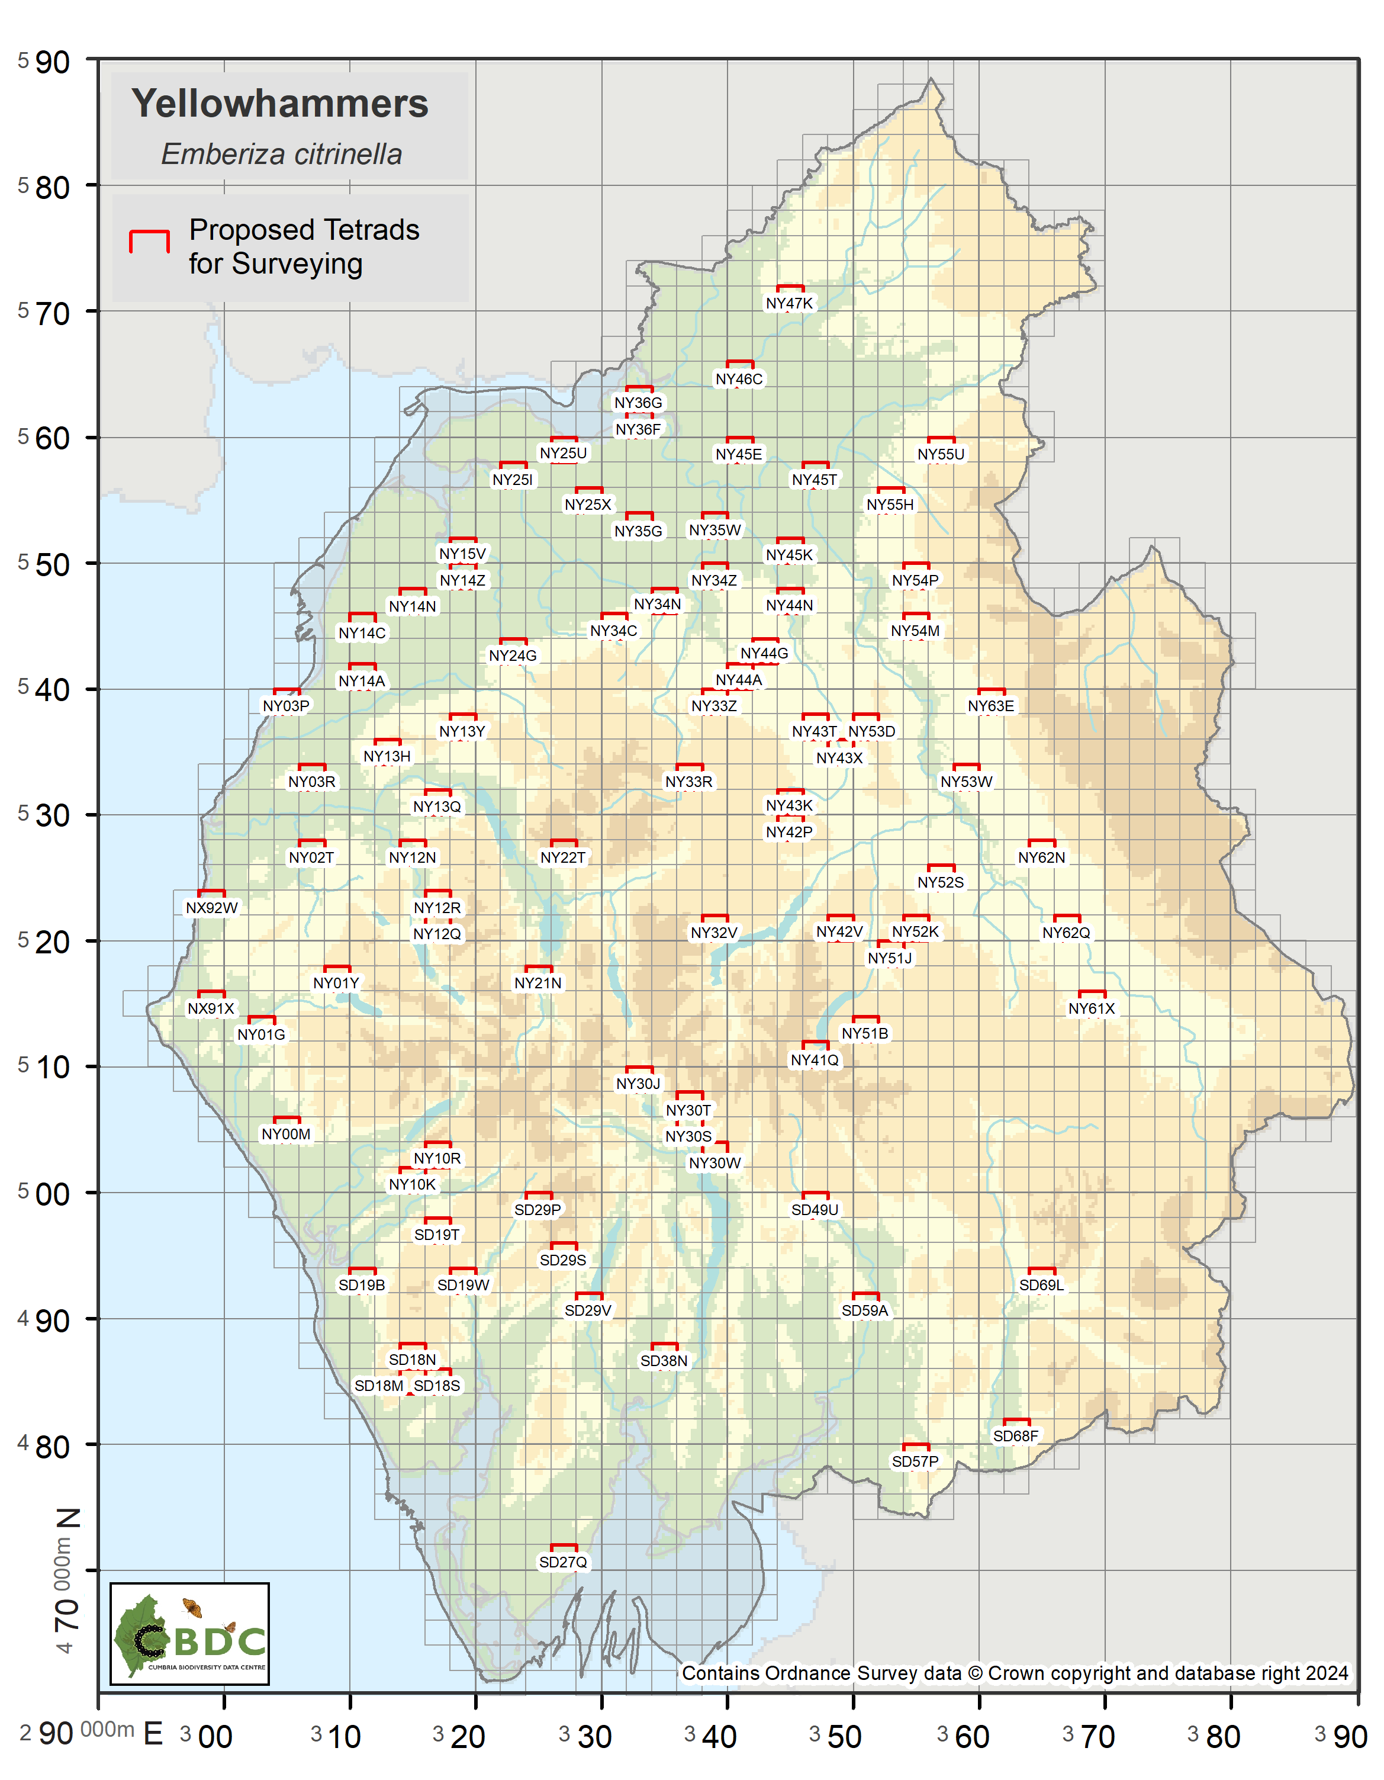
Figure 2: Survey tetrads by reference number (NOTE: the tetrads are the same as in Fig. 1)

